It’s Old Home Week!

The twin pulls of urban industrialization and westward migration that overtook America after the Civil War was devastating to many small towns in New England and the Middle Atlantic States. In the four decades ending in 1900, despite massive European immigration, the population of many small towns had seriously declined. Farms were abandoned and the towns’ economies eroded.

Frank Rollins of New Hampshire, son of a former New Hampshire U. S. Senator, worried for the future of his hometown. In 1897 he wrote “I wish that in the ear of every son and daughter of New Hampshire, in the summer days, might be heard whispered the persuasive words: Come back, come back! Do you not hear the call? What has become of the old home where you were born? . . . Do you not remember it — the old farm back among the hills, with its rambling buildings, its well-sweep casting its long shadows, the row of stiff poplar trees, the lilacs and the willows?”

Rollins became Governor of New Hampshire in January 1899 and the first Old Home Week celebrations were held in 44 towns throughout New Hampshire that summer.

The concept spread throughout New England. This card shows the decoration heaped on the local post office in Belfast, Maine.

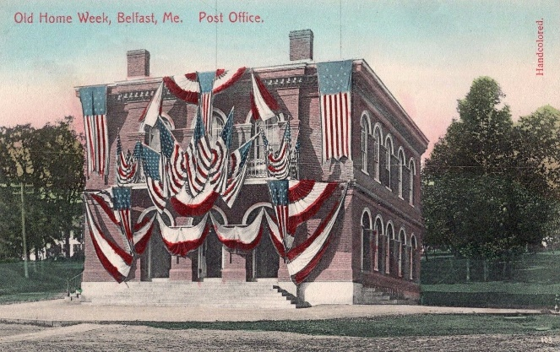

And this card, from North Adams, Massachusetts, touts the vitality and the beauty of this Berkshire Mountains town.

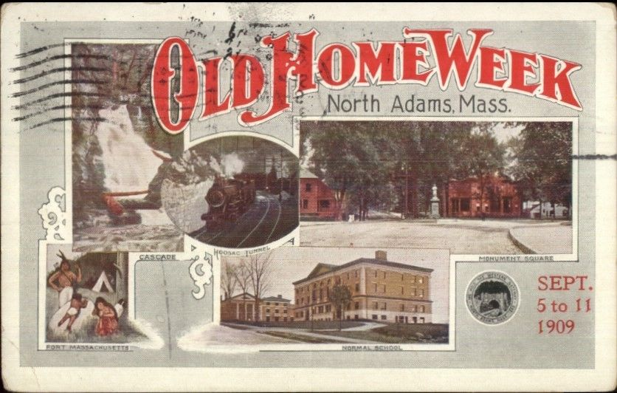

Or this probably locally made card from Attleboro, Massachusetts.

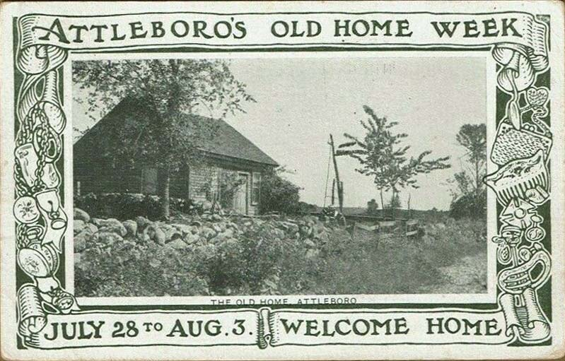

And it wasn’t just the small towns that sought to attract their emigrants. Boston, Massachusetts, for example, held its Old Home Week celebration in 1907, as shown in these two cards.

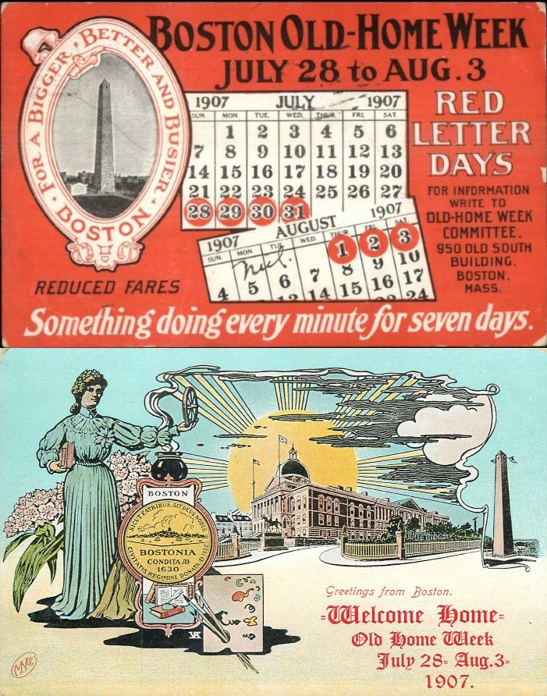

And Newport, Rhode Island, went all out with parades that featured floats sponsored by local businesses.

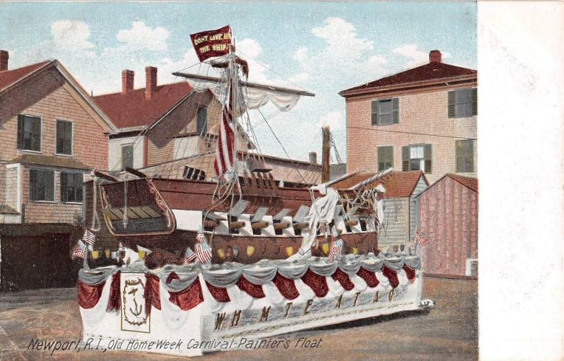

Many of the small towns in New York and Pennsylvania had also lost large numbers of their citizens to westward migration from their less-than-hospitable soil. These towns made major efforts to bring their prodigal children back.

For example, Buffalo, New York combined Old Home Week with the dedication of the monument to President William McKinley (who was martyred there) in 1907.

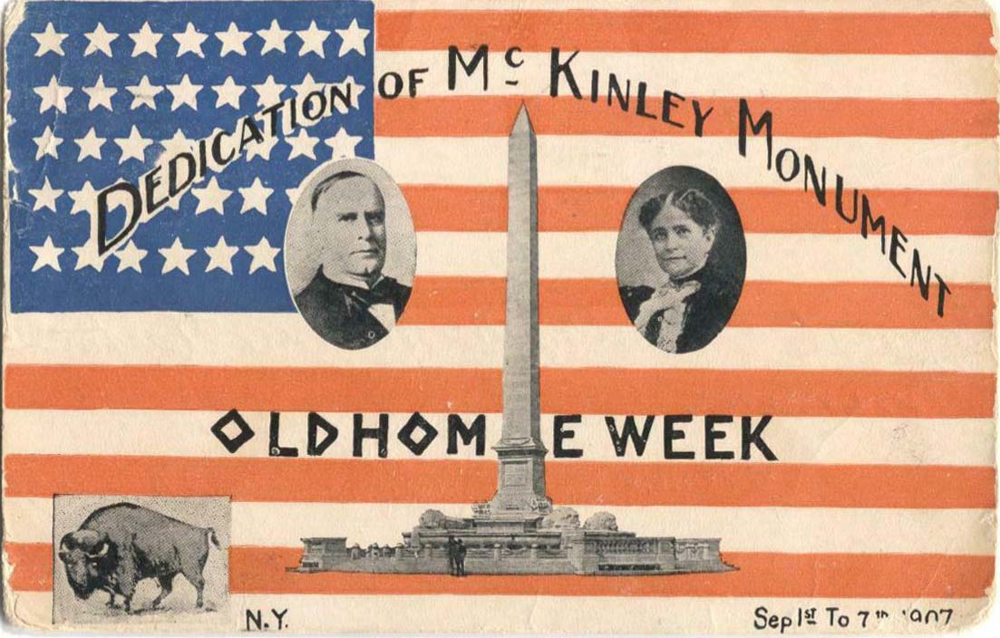

This is the official Old Home Week card for the Buffalo celebration.

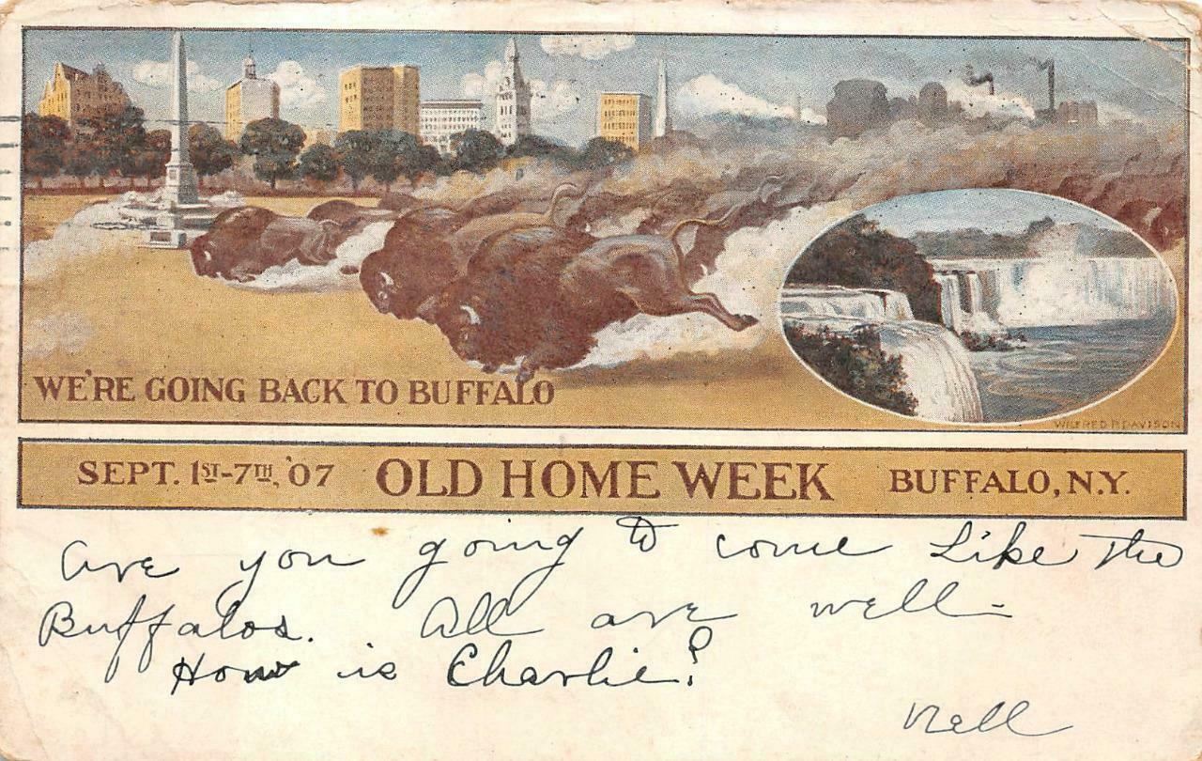

Some small towns didn’t (or couldn’t) spend the money on such flashy announcement cards, preferring to memorialize the event. This real-photo card from the very small town of Conneautville, Pennsylvania (near the Ohio state line), for example, shows the crowds at the celebration in town.

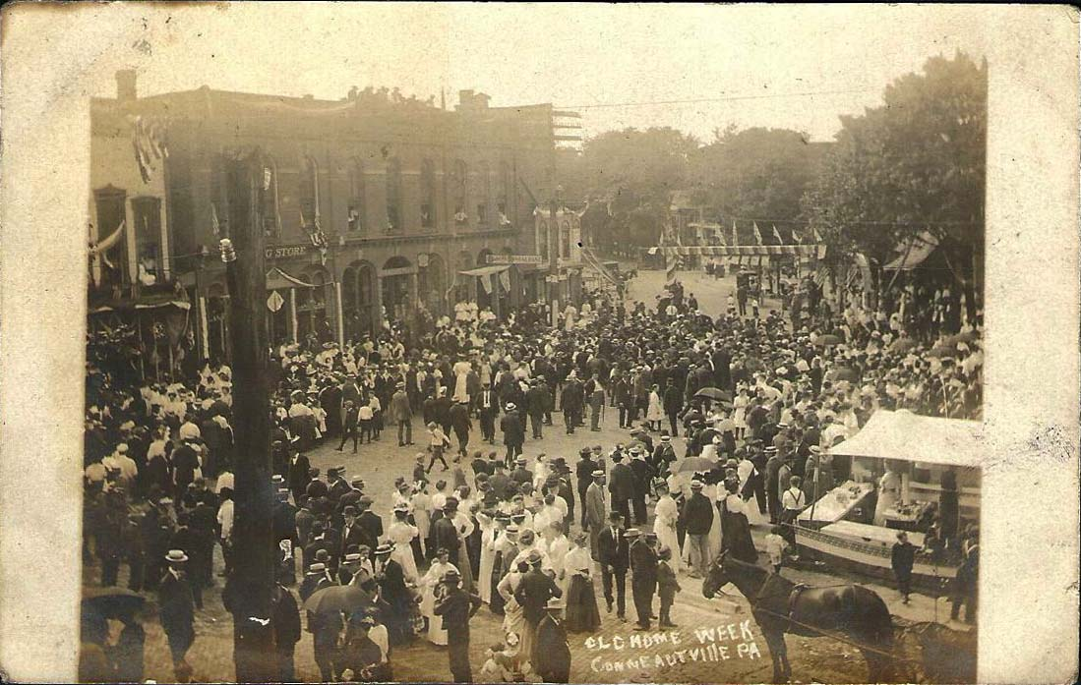

The state capital, Harrisburg, on the other hand, couldn’t restrain itself.

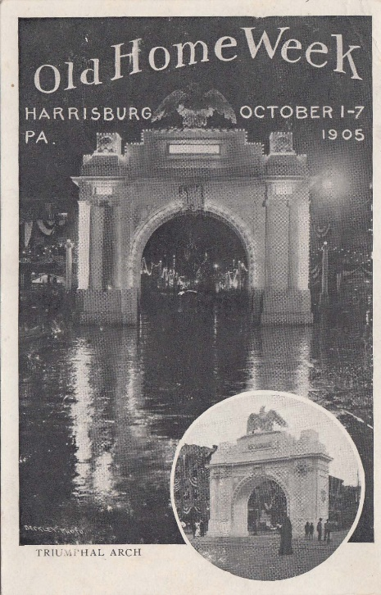

Further south and west, celebrations in the era were held in Baltimore, Maryland, in what must have been a banner year for Old Home Weeks, 1907.

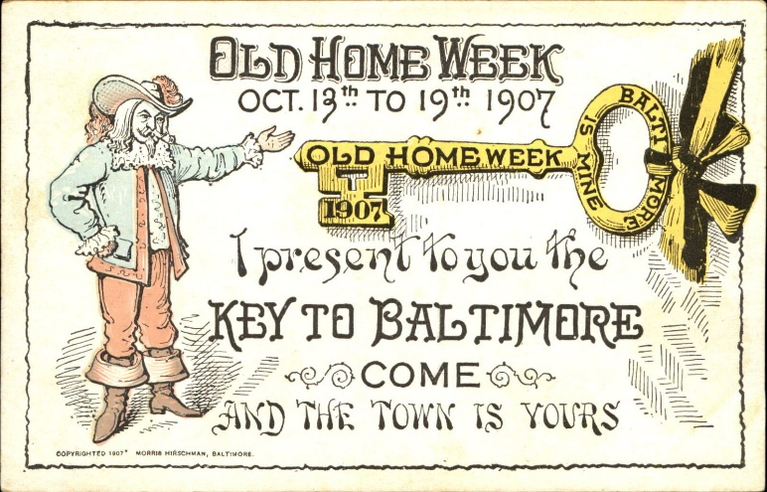

States far away from the eastern seaboard caught the bug as well. Oshkosh, Wisconsin, for example, held a celebration in 1908.

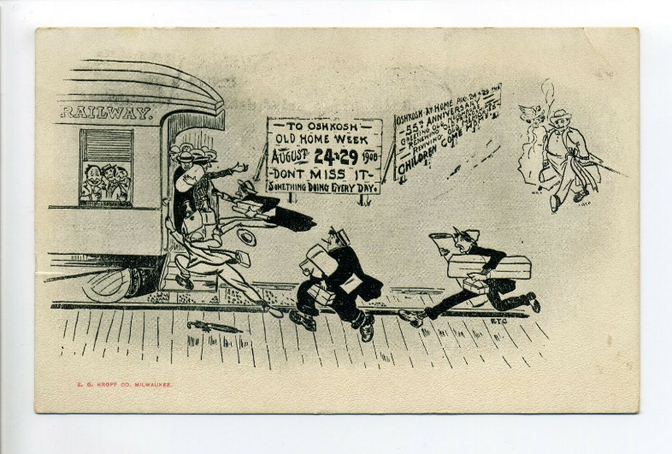

Some people must have thought poetry would bring returnees. Such as on this card from Belevedere, Illinois.

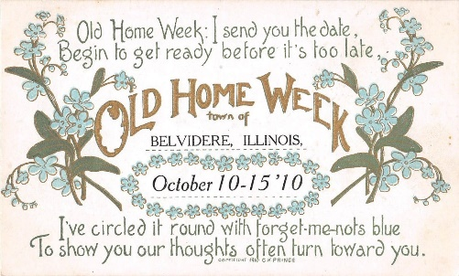

To save money, some communities used postcards they already had of their communities and just printed a message of invitation on the back. Here’s one from Youngstown, Ohio.

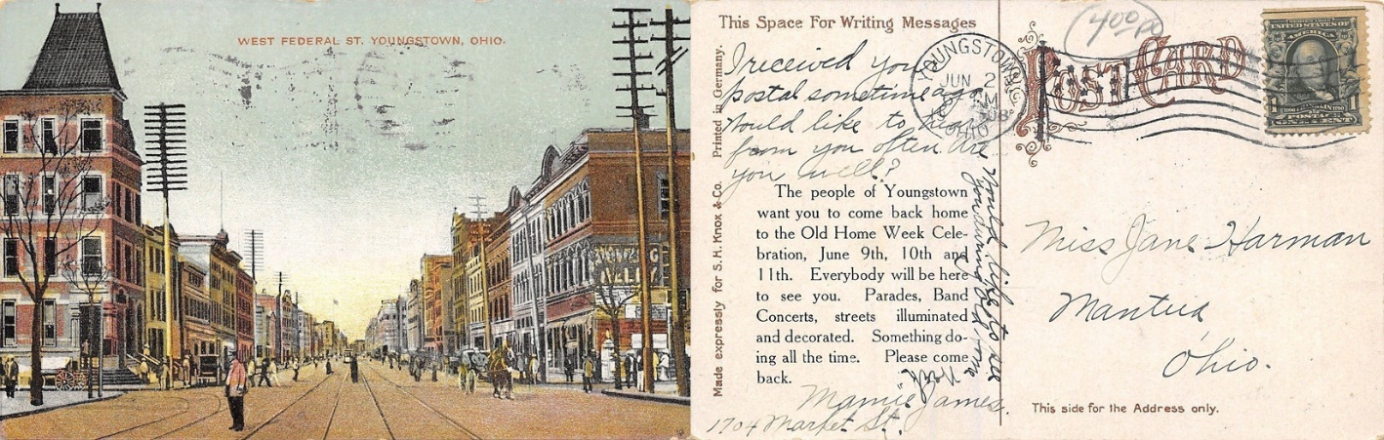

Finally, there is always advertising and souvenirs. The wheel on this card turns to reveal approximately 12 Boston views — courtesy of La France Shoe Company of Lynn, Massachusetts.

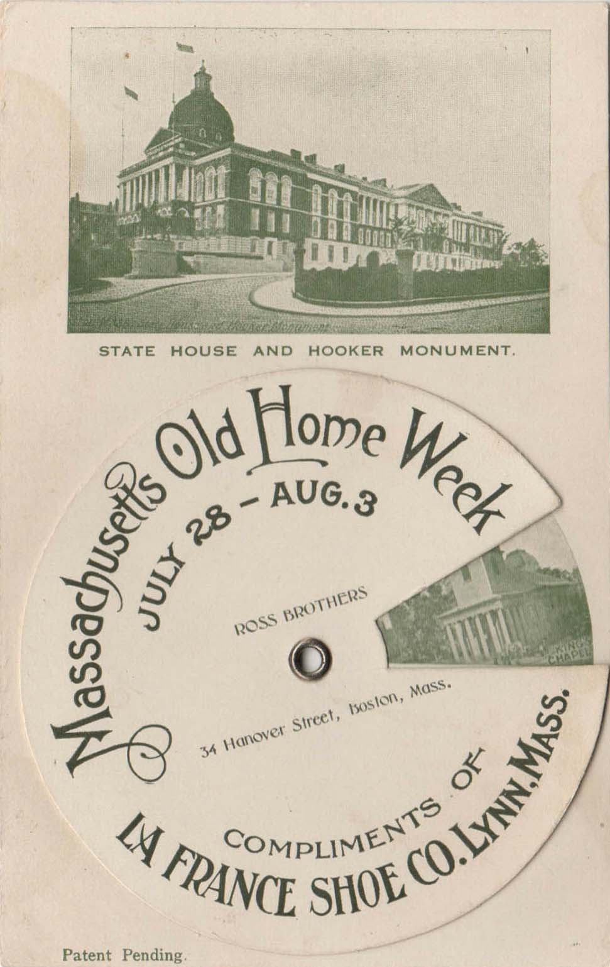

And this card doesn’t even bother trying for local patriotism.

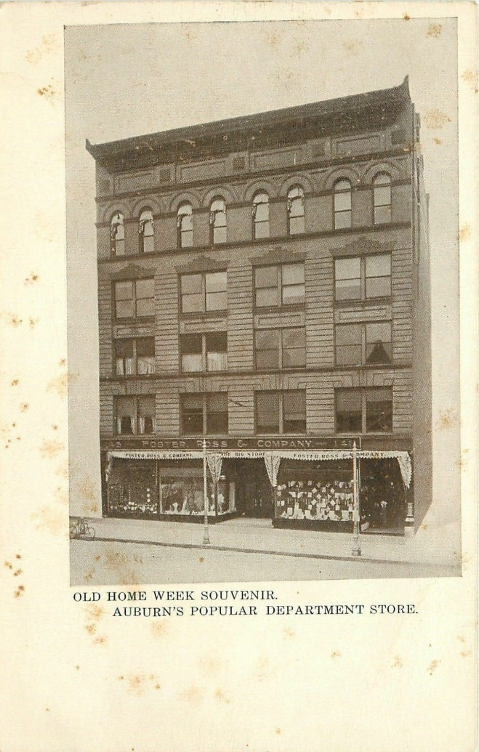

And what would these celebrations would have been without a souvenir pin? This one is from Gouveneur, in New York state near the Canadian border.

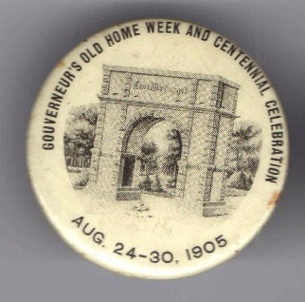

The Old Home Week movement survives today and is not confined to its original purpose. Several communities in various parts of the U. S. combine Old Home Week celebrations with historical and centennial celebrations, for example. It is, after all, the thought that counts.

