Convert webp to jpeg = https://www.freeconvert.com/webp-to-jpg/download
HTML can’t be converted — use snipping tool which comes out as .jpeg

Kevin, where I highlight a word or phrase in yellow, that’s where the link that follows should be. Don’t keep the yellow, though.

News and
Noteworthy

March 15 2023

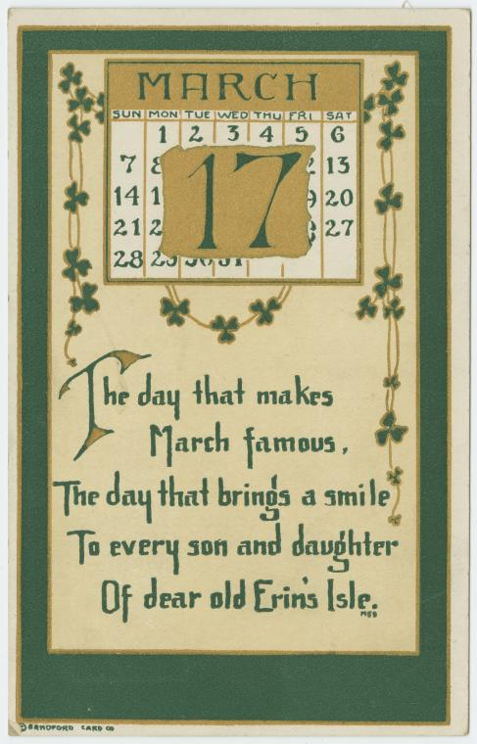

We love it when St. Patrick’s Day arrives. https://www.nypl.org/blog/2020/03/17/st-patricks-day-vintage-postcards We’re past the Ides of March (when Julius Caesar was assassinated) and rolling into the official start of Spring (at least here in the northern hemisphere) when daffodils begin to bloom all over the place. In between there is a whole lot of green being worn, green beer makes its annual (and only) appearance, corn beef and cabbage is served in places that never do it, and buttons appear that say “Kiss Me, I’m Irish.”

___________

Nightingale, the “Journal of the Data Visualization Society,” has posted a terrific exhibition Information Graphics in Action: Russian Agitational Postcards 1900–1960. https://nightingaledvs.com/information-graphics-in-action-russian-agitational-postcards-1900-1960/

We agree, the above is a mouthful, but you’ll get over that hump when you see the propaganda postcards that are in the exhibit. There’s also very informative text (in English) accompanying the cards. Take a look.

