Convert webp to jpeg = ––––https://www.freeconvert.com/webp-to-jpg/download
HTML can’t be converted — use snipping tool which comes out as .jpeg

Kevin, where I highlight a word or phrase in yellow, that’s where the link that follows should be. Don’t keep the yellow, though.

News and
Noteworthy

June 7, 2023

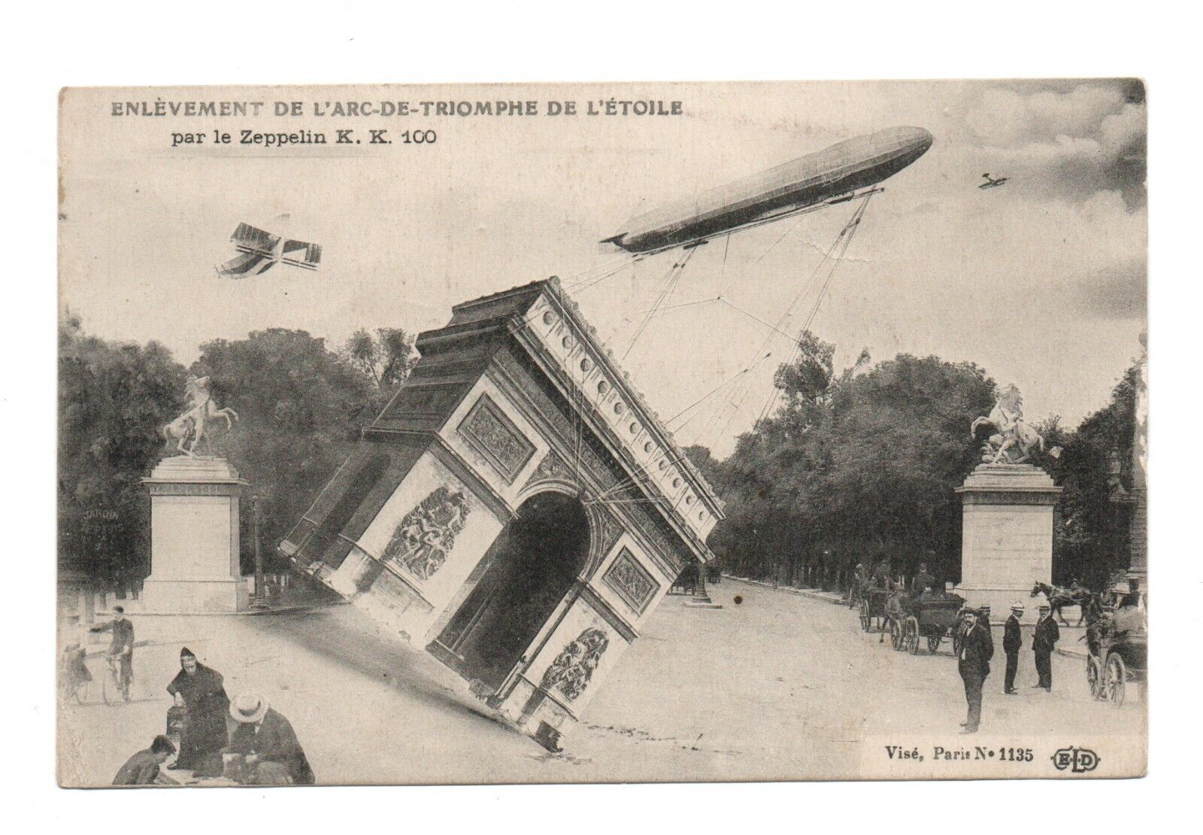
World War I so ratcheted up the ability to rain death and destruction to the enemy and its soldiers on the ground that innovations took on a life of their own. The Zeppelin, floating high above ground, could dispense bombs at will. The bombing of many European cities from 1914 through 1918 are just a part of the talk Steve Suddeby https://thedigitalphilatelist.com/philatelic-society-of-lancaster-county-zeppelin-postcards-in-world-war-i/ presented to the Philatelic Society of Lancaster County in 2021.

__________

Smokey C Tennison (“Snail Mail with Smokey”) raises an interesting point about postcard publishers — what do you do when the competition becomes so fierce that you’re in trouble? His answer? Create something different than any of your competitors have. His point is that the reason for leather postcards https://thedigitalphilatelist.com/snail-mail-with-smokey-episode-24-leather-postcards/ coming into being was exactly that — competition, not just good will. The business of postcard publishing must have seemed cut-throat in the 1900s.

