Convert webp to jpeg = ––––https://www.freeconvert.com/webp-to-jpg/download
HTML can’t be converted — use snipping tool which comes out as .jpeg

~ 14 lines plus separator for 2 entries + vertical illustration

News and
Noteworthy

February 14, 2024

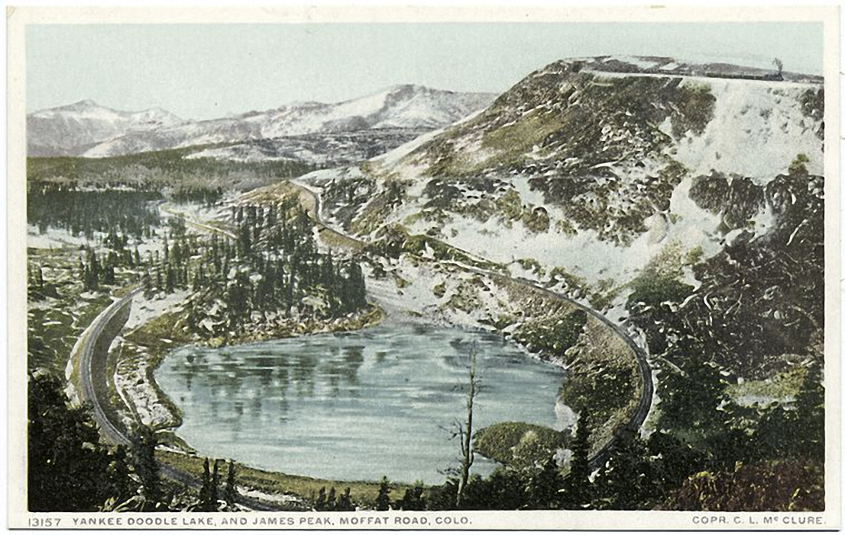

The weather of late reminds us of the weather of old. Finding appropriate postcards of bygone storms can be tough, but we figured there was no better place to turn than the resources of the New York Public Library’s Digital Collections. In particular, the Detroit Publishing Company’s postcards donated by Leonard Lauder has over 14,000 cards, helpfully sorted by series number. The sample above is from Series 13,000 and still exists today as part of the Roosevelt National Forest in Colorado.

_______________

Readers are not likely to agree with the subtitle of this Flashbak.com post “Postcards are cool again. Collect and gift gorgeous art on a budget.” Nevertheless, we recommend you browse this longish article for the unusual fun that these postcards show and the accompanying text.

